**Application Analysis Report**

Min Zan a1673755

**Background**

Waste recycling is a truly meaningful activity. Through the way of cultivating the people the awareness of waste sorting, different categories of garbage can be placed in different types of garbage bins, which will greatly improve the possibility and efficiency of garbage recycling. Therefore, this method has been widely used in various places.

The University of Adelaide has also actively promoted garbage recycling strategy. It has placed 3 different categories of recycling bins in campus and carried out a wide range waste collection educational activities. These actions have achieved certain success. However, according to “University of Adelaide Hub Central Waste and Recycling Review”, there are still some problems and the biggest issues are:

* 66% of all items that were disposed of into bins, were placed in the correct bin;
* 34% of items were placed in the incorrect bin.
* When a student obviously looked at the bin signage, **81%** of the time they placed the item in the correct bin; compared to
* When a student did not obviously look at the signage on the bin stations, only **53%** of the time they placed the item in the correct bin.

Therefore, in order to solve above problems, enhance the recycling awareness among students and increase the accuracy of garbage classification, a gamifying waste recycling software application has been proposed, which is aimed to provide more interactive waste management education.

**Product positioning**

* 1. Product definition

It is a gamifying waste recycling education application, especially for the student of University of Adelaide.

* 1. Users

This application is mainly for the student of Adelaide, particularly for the student in North Terrence campus. The major features of these users are:

* The age of them are generally elder than 18, which means most of them are adult student.
* There are great amount oversea students with multi-cultural background.
* Hub and other teaching building are their main activity venues.
* Studying, socializing and taking meal are their primary activities in campus.

Based on this, if the design of this application must take great consideration of these factors. One of them is the psychology of adult learning mechanism:

1. The adult must be influenced by prior knowledge during learning process. To stimulate association, comparison and thinking psychologies based on these experiences is the basic approach to improve the efficiency of understanding the new knowledges.
2. Problem-based or task-based learning model are more fit for adult students, which is also a huge difference from junior students.
3. The purpose of adult study is more tend to utility.
4. Self-study.
5. Adult learning emphasis on personal experience and practicability

The motivations of Adult learning are:

1. The need of social activity.
2. The Need for social stimulation.
3. The need for external expectations.
4. To serve the needs of social organizations.

According the classical feedbacks of survey, it shown that the colour symbol system does play a great role for garbage collection. Because there are no barriers for multi-cultural students to improve the efficiency of garbage classification by recognizing the colours and symbols.

However, the current symbol colour system is still not very perfect. So in this application, we will try to improve the information delivery of colour s and symbols.

***Law Student – Inside Bin***

*“I find the bins to be confusing that I am not really a fan of the “bin monsters”. Even though I know what to recycle, I still find the bins confusing and I am not sure of the purpose of the little sign is. There is also no need to include that the general waste goes to landfill as we already know that it does. It would be better to make the signage simpler.”*

***Arts Student – Inside bin***

*“I find the bins to be confusing and you really have to look hard to see what goes in. The artwork is nice but I am not sure if it is helping people put the right things in the right bins.”*

This application will use the gamifying way to attract young people's interest. In the game, based on the learning characteristics and motivations of adult students, we apply some specific design combining with colour and symbols to achieve the best education effects.

**Analysis of relative products**

**1**. [Port Adelaide Enfield - Stuff for Kids](http://www.portenf.sa.gov.au/page.aspx?u=1040)

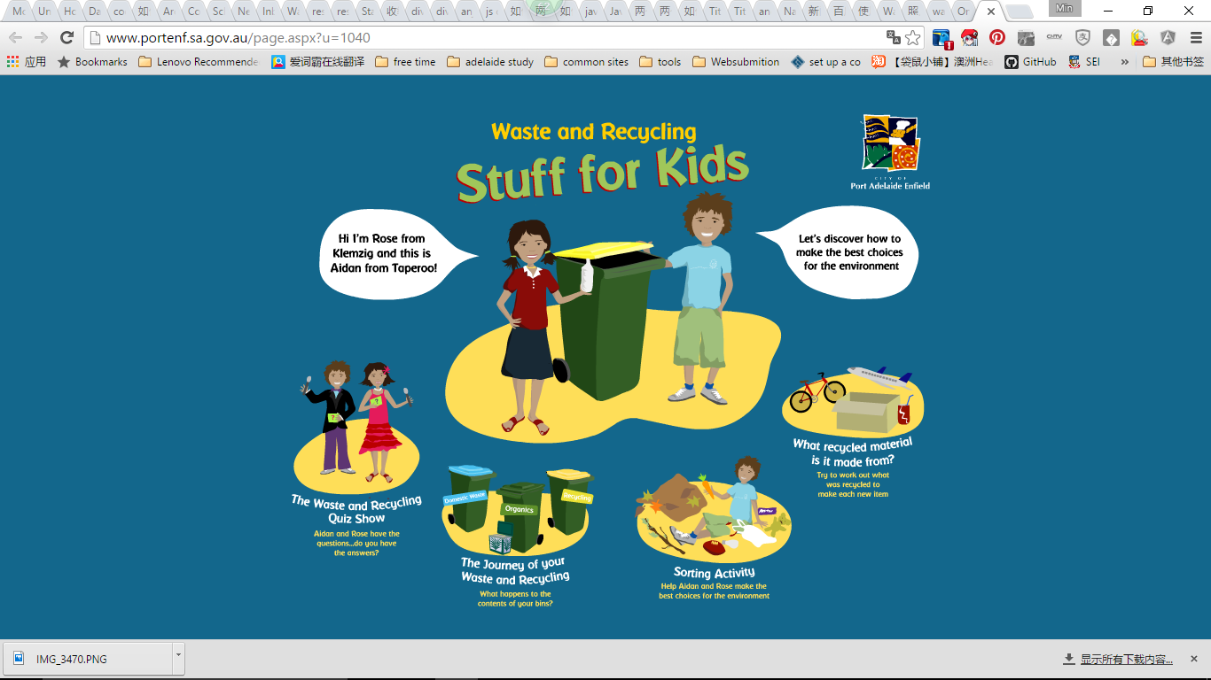

<http://www.portenf.sa.gov.au/page.aspx?u=1040>

|  |  |  |  |
| --- | --- | --- | --- |
| **product** | **Target user** | **product positioning** | **Main functions** |
| Stuff for Kids | **Kids** | **General knowledge of waste reuse** | **Gamifying Education** |
| **Interaction** | **Interface** | **Game features** |
| **Information in traduce**  **Click, drag**  **Quiz**  **Interact with game characters** | **quasi-physical design**  **Vivid colour**  **Very suitable for Kids**  **Use cartoon characters** | **Use character introduce information, 4 scenes** |
| **Advantages** | **Beautiful interface, use cartoon characters，4 scenes**  **Introduce the whole life cycle of waste management. Beside general recycle knowledge, it also introduces charity and reuse sorting.** | | |
| **Disadvantage** | **High-cost of development. The knowledge is quite simple. Games are built by Flash. It cannot be used in mobile phones. No mobile App。No user register and interaction.** | | |

2. Waste & recycling games

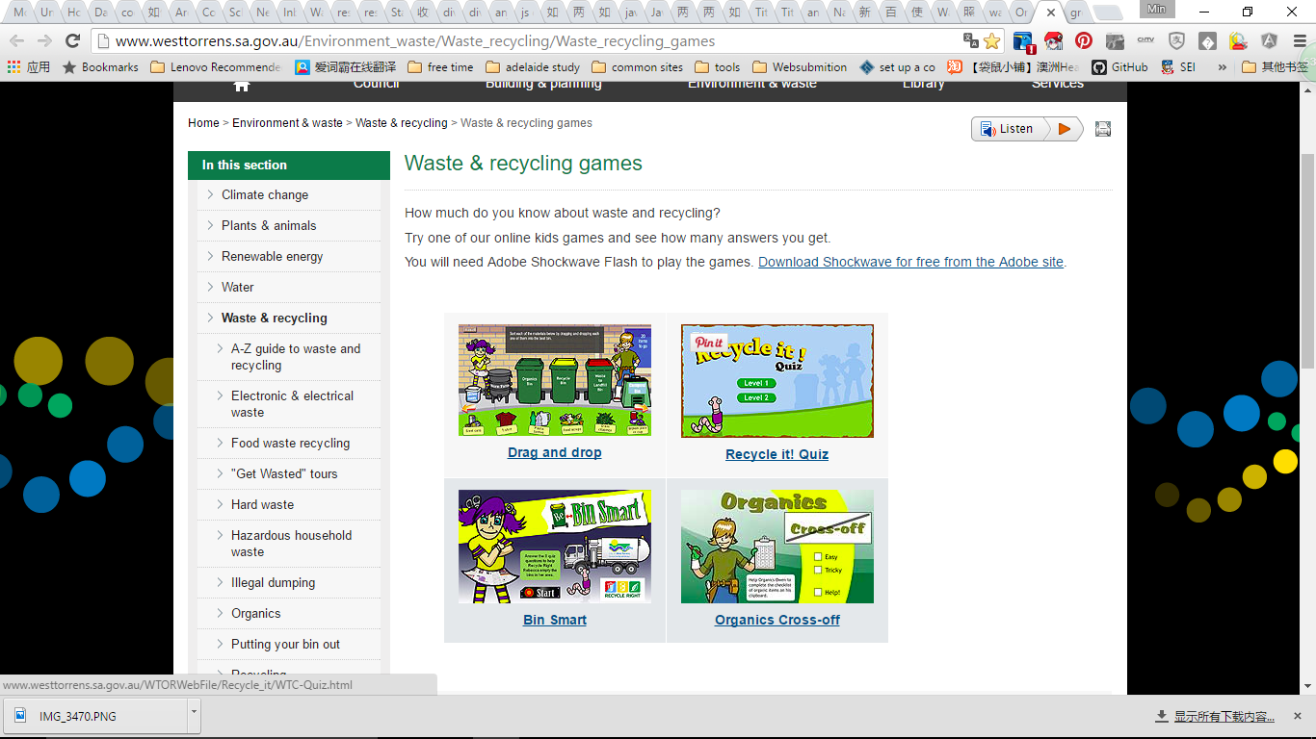

<http://www.westtorrens.sa.gov.au/Environment_waste/Waste_recycling/Waste_recycling_games>

|  |  |  |  |
| --- | --- | --- | --- |
| **product** | **Target user** | **product positioning** | **Main functions** |
| City of west torrens Waste & recycling games | **Citizens** | **Municipal Services** | **Game and information provide** |
| **Interaction** | **Interface** | **Game features** |
| **Drag**  **Quiz**  **click** | **quasi-physical design**  **Vivid colour**  **Animations** | **Puzzle** |
| **Advantages** | **Vivid interface. Games are especially for waste sort Audio effects and animation is good** | | |
| **Disadvantage** | **High-cost of development. Quiz are very simple. The game is also very easy. Games are built by Flash. It cannot be used in mobile phones. No mobile App。No user register and interaction.** | | |

* 1. Zero wate Game

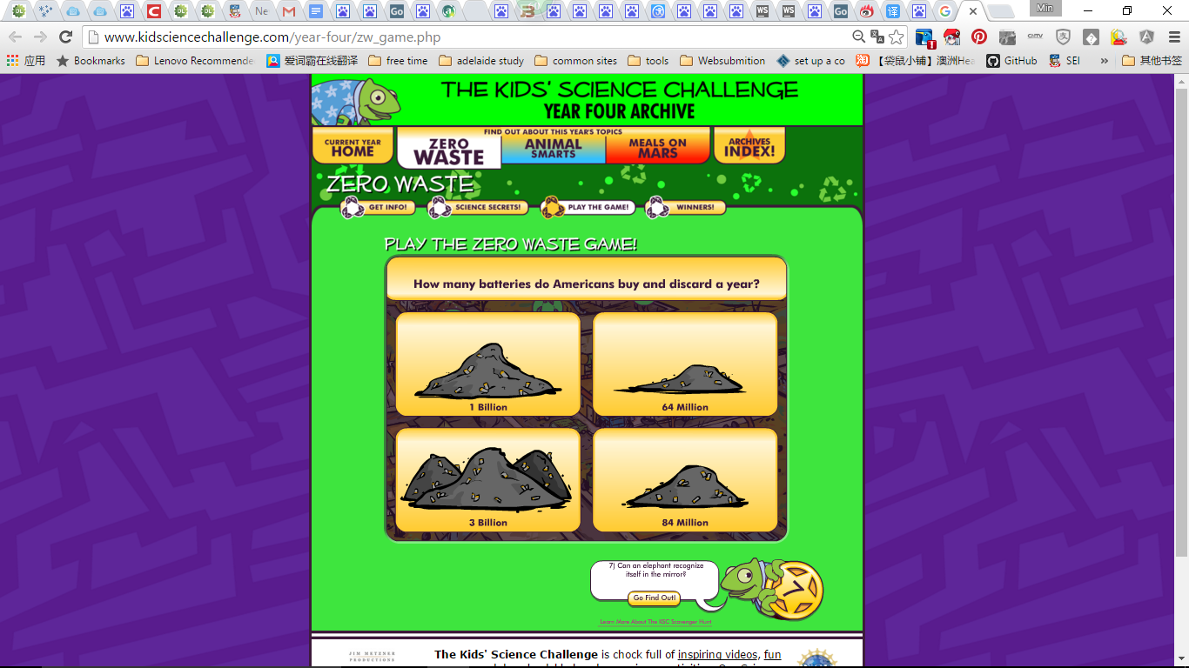

<http://www.kidsciencechallenge.com/year-four/zw_game.php>

|  |  |  |  |
| --- | --- | --- | --- |
| **product** | **Target user** | **product positioning** | **Main functions** |
| Zero wate Game | **Kids** | **Science challenge** | **Gamifying education** |
| **Interaction** | **Interface** | **Game features** |
| **quiz** | **quasi-physical design**  **Vivid colour**  **Very good for kids** | **Puzzle** |
| **Advantages** | **The inter face is very good. Audio effects and animation is good** | | |
| **Disadvantage** | **High-cost of development. Quiz are very simple. No relationship with waste sorting. Games are built by Flash. It cannot be used in mobile phones. No mobile App。No user register and interaction.** | | |

4. **GreenApes**

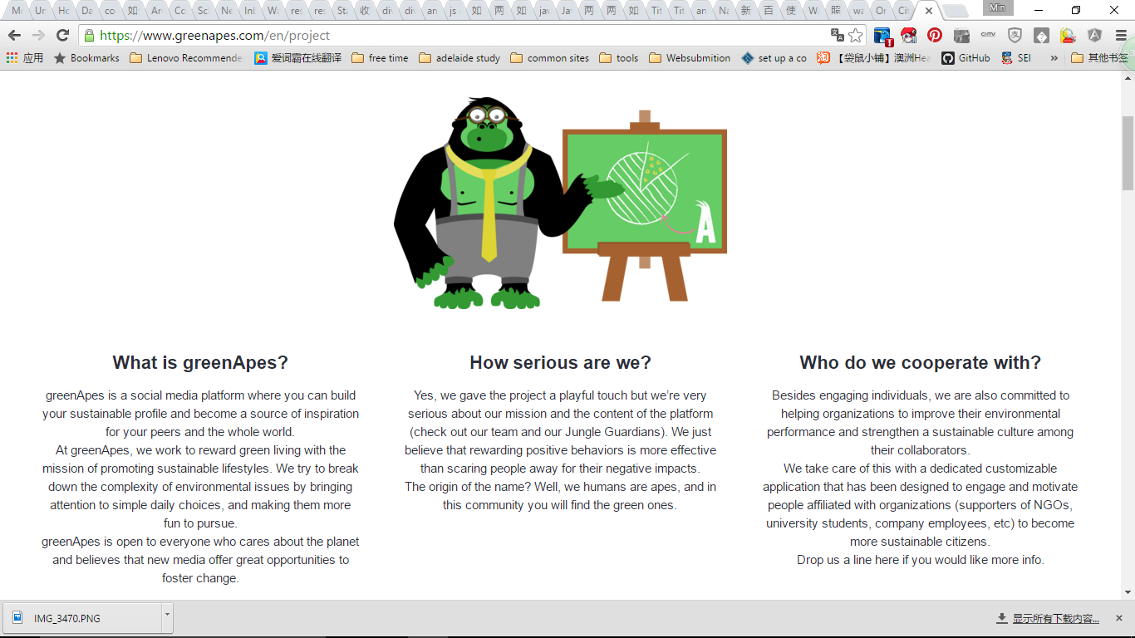

[**https://www.greenapes.com/en/project**](https://www.greenapes.com/en/project)

|  |  |  |  |
| --- | --- | --- | --- |
| **product** | **Target user** | **product positioning** | **Main functions** |
| **GreenApes** | **The young** | **Focus on sustainable development** | **Social network game. Task publish.** |
| **Interaction** | **Interface** | **Game features** |
| **Touching.**  **Information pic Post** | **Flat design**  **Vivid color and**  **Characters** | **Social network game** |
| **Advantages** | **Very professional development team.**  **Totally based on mobile application**  **Totally based on social network interaction.**  **Total an internet product**  **Advance technique**  **Suitable for young people**  **New idea of Green application** | | |
| **Disadvantage** | **Nothing about waste soring. No game. Only a platform.**  **Very difficult for development.** | | |

5. **Brainturk**

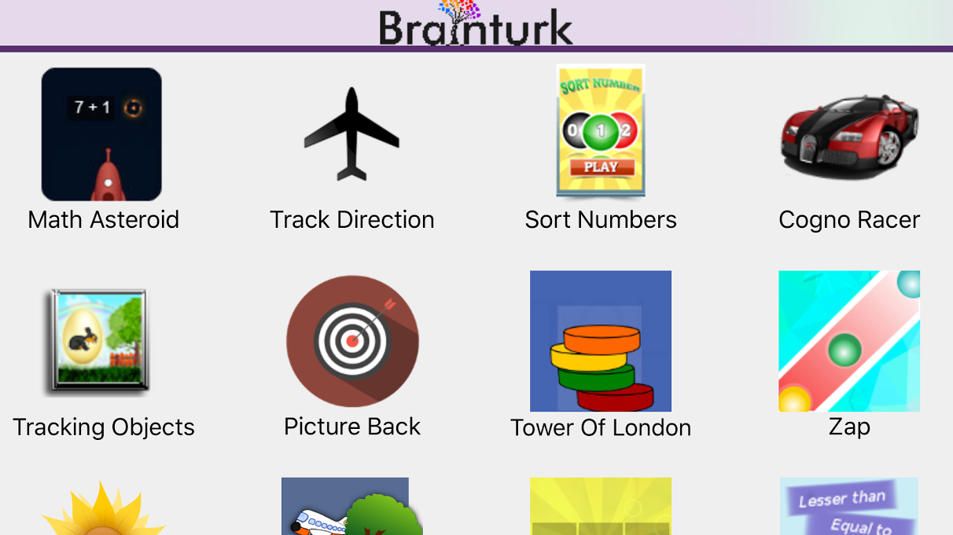

**https://www.brainturk.com/**

|  |  |  |  |
| --- | --- | --- | --- |
| **product** | **Target user** | **product positioning** | **Main functions** |
| **Brainturk** | **Adult** | **Brain training** | **Many different small games** |
| **Interaction** | **Interface** | **Game features** |
| **Simple operations**  **Click, drag** | **Flat design combines with quasi-physical design**  **Icons are in different styles not very good** | **Mainly Puzzles** |
| **Advantages** | **Various of simple games. Low development cost.**  **Provide both web game and mobile applications.** | | |
| **Disadvantage** | **The interface design is not very good. It is very like Elevate, but the effects are poor. No games about waste sorting. No user register and interactions.** | | |

**Conclusion**

|  |  |
| --- | --- |
|  | **What we can learn from it** |
| **Stuff for Kids** | **Cartoon characters. 4 scenes.** |
| **City of west torrens Waste & recycling games** | **Classic game design for waste sorting.**  **Webpage provide lots of waste soring information.**  **Good animation and sound effects** |
| **Zero wate Game** | **Interface design** |
| **GreenApes** | **Social network game, social interaction** |
| **Brainturk** | **Small game design** |

At present, there are some problems in the educational game of garbage collection

* Most of these games are aimed at children. So the design of the game is based on children's characteristics.
* These games’ interfaces are quasi-physical design. The visual effects are excellent, but the game content is too simple.
* Most of these games more are made by Flash technology, which is not suitable for deploying in mobile terminal.
* Most of these games do not provide user interaction, such as comments, sharing and so on.

Most of internet based products do not focus on waste sorting this specific goal. So, the mobile application for college students' garbage collection and reuse education is even rare.

Our application will be a combination of the latest Internet technology, adult students learning psychology, and the features of University of Adelaide itself. Hence it is very special.

**Main functions**

This application basically probed to main parts of functions.

1. Information delivery. Mainly about waste recycling news and campus news.
2. Waste management games.

**Product features**

The features of this application are:

1. **Gamifying Education**

In order to attract young users, we improve the traditional way of recycling education. Usually these waste recycling knowledge is published on internet. Users browse this information and learn. This effect of this approach is not good. So we adopt gamifying ways as an important means of our education application design. By Integrating the key points of waste management knowledge into small game so, we can achieve better outcomes. At the same time, considering that the education is the substantial goal of this application, so the game plot is not very complicated. The game is also with simple logic. Game interface does not have to be particularly complex. It could be achieved by flat design style, which will save a lot of development costs. It also follows the current design trend.

1. **Adult student learning psychology.**

This part has been described in user analysis section. Here is just to emphasize that game design should be fully considered this factor. For example, appropriately increasing the difficulty of games, cutting some introduce of experience knowledge (basic knowledge of waste recycling), increasing thinking and association designs, increasing the incentive mechanism and increasing social interactive functions.

1. **Color and symbol**

Color and symbol are critical for waste identification and classification. Due to multiple international student background, it is a useful tool for information delivery. We will try to improve the existing problems (sign recognition is not clear) in designing game. Cross-references is below:

|  |  |  |
| --- | --- | --- |
| Recycling = Yellow | Waste (landfill) = Red | Food Scraps = Green |
| Empty Coffee Cups | Chip packets | Apple cores |
| Magazines/leaflets | Lolly wrappers | Mandarin peel |
| Newspaper | Soft plastic wrap | Sandwich |
| Cans | Plastic bags | Hotdog |
| Glass Bottles | Take away containers with food | Tea bags |
| Cartons | Coffee cups with liquid | Paper towel |
| Plastic Bottles | Bottles/cans with liquid | Tissues |

1. **Waste recycling**

To make the game more specific. Waste recycling is the most important aim should be considered in our application. What should be emphasised here is that the game design must be more specific based on the survey. For instance, the survey shows that:

*The analysis found that coffee cups are a major component of the waste stream, and analysis of the audit data indicates approximately:*

***300*** *coffee cups are disposed of at the Hub each day (****57%*** *into the* ***general waste bins*** *and*

***43%*** *into the* ***recycling bins****); and*

***73,000*** *coffee cups are disposed of at the Hub each year.*

Hence a game could be designed to solve coffee cup collecting. Another example is that almost 16% recyclable containers that in fact could not be recyclable because these are still food waste in them. A game could be designed based on this.

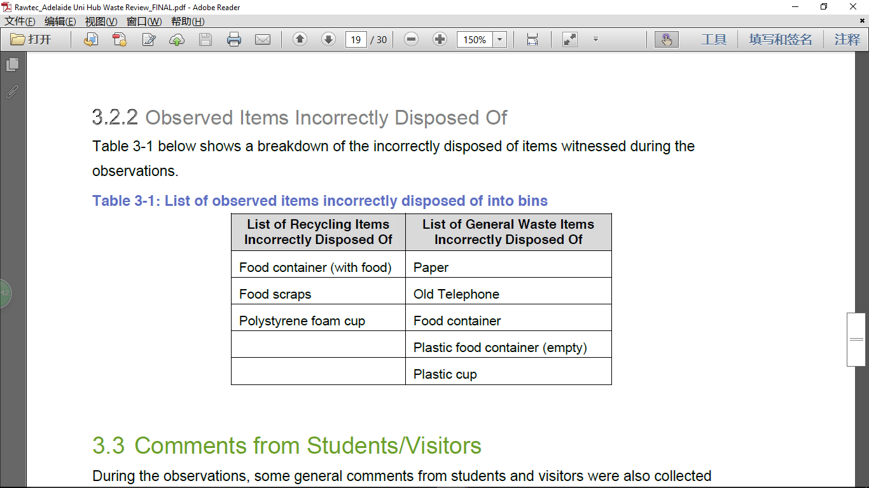

1. **Social network interaction**

In order to increase the adhesion of this application. It should be added more interactive functions. For example, student could share the and comment through Facebook. It is an important way to increase the user experience of this application. It is also a basic requirement of current applications.

**User requirement**

1. **Use case analysis**

|  |  |
| --- | --- |
| **Target user** | **Key words** |
| **The students of University of Adelaide** | **Acquire latest waste management information，increasing the interaction with other students. Interesting games.** |

|  |  |
| --- | --- |
| **Use scenario** | **Key words** |
| **In campus** | **Check information，gaming, could find the bins in Hub** |
| **At home** | **Check information，gaming** |

|  |  |
| --- | --- |
| **User’s goal** | **Key words** |
| **Acquire information** | **Latest news ，information push** |
| **A guide when puzzling which bins should be put the waste** | **Colour, symbol, information** |
| **Prize** | **Gaming, task** |
| **Entertainment** | **Beautiful interface, attractive games** |
| **Interaction** | **Comment, share** |

1. **Some advices**

In order to increase the adhesion of this game. Some functions could be considered to add into this application.

* Some tools. such as web site navigation (Useful study Web site and so on.)
* Reward mechanism.
* Campus promotion, online and offline activities
* Hub Tips (Introduce how to rent boxes in hub, Hub maps, Hub facilities)
* Event and news on Hub (Club events hold in hub)

1. **Other advice**

Due to the major garbage in Hub is food waste. Perhaps we can paste recycle color logo on coffee cup and food containers used in Hub shop. These logos could come from our game. The whole color symbol system covers form the generate source (Hub shop) to the recycle source (recycle bins).

。

Uniformity of Color symbol